**Exercise 1: Configuring a Basic Spring Application**

**Code:**

**Pom.xml:**

<project xmlns="http://maven.apache.org/POM/4.0.0" xmlns:xsi="http://www.w3.org/2001/XMLSchema-instance" xsi:schemaLocation="http://maven.apache.org/POM/4.0.0 https://maven.apache.org/xsd/maven-4.0.0.xsd">

<modelVersion>4.0.0</modelVersion>

<groupId>com.library</groupId>

<artifactId>LibraryManagement</artifactId>

<version>0.0.1-SNAPSHOT</version>

<dependencies>

<dependency>

<groupId>org.springframework</groupId>

<artifactId>spring-context</artifactId>

<version>5.3.33</version>

</dependency>

</dependencies>

</project>

**BookRepository.java**

package com.library.repository;

public class BookRepository {

public void saveBook(String bookTitle) {

System.out.println("Saving book: " + bookTitle);

}

}

**bookService.java**

package com.library.service;

import com.library.repository.BookRepository;

public class BookService {

private BookRepository bookRepository;

// This setter method is used by Spring to inject the BookRepository

public void setBookRepository(BookRepository bookRepository) {

this.bookRepository = bookRepository;

}

// This method simulates adding a book

public void addBook(String title) {

System.out.println("Adding book to service: " + title);

bookRepository.saveBook(title); // delegate to repository

}

}

**MainApp.java**

package com.library1;

import com.library.service.BookService;

import org.springframework.context.ApplicationContext;

import org.springframework.context.support.ClassPathXmlApplicationContext;

public class MainApp {

public static void main(String[] args) {

// Load Spring configuration file

ApplicationContext context =

new ClassPathXmlApplicationContext("applicationContext.xml");

// Get the BookService bean from the context

BookService bookService = (BookService) context.getBean("bookService");

// Call the method to add a book

bookService.addBook("The Great Gatsby");

}

}

**applicationContext.xml**

<?xml version="1.0" encoding="UTF-8"?>

<beans xmlns="http://www.springframework.org/schema/beans"

xmlns:xsi="http://www.w3.org/2001/XMLSchema-instance"

xsi:schemaLocation="

http://www.springframework.org/schema/beans

http://www.springframework.org/schema/beans/spring-beans.xsd">

<bean id="bookRepository" class="com.library.repository.BookRepository" />

<bean id="bookService" class="com.library.service.BookService">

<property name="bookRepository" ref="bookRepository" />

</bean>

</beans>

**Output:**

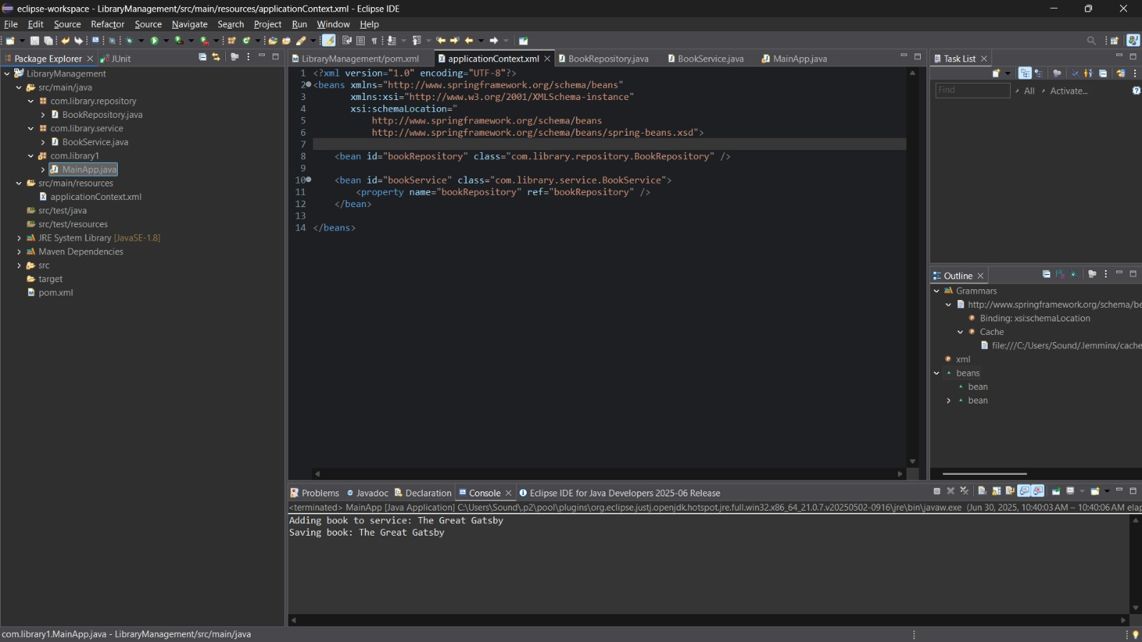

**Exercise 2: Implementing Dependency Injection**

**Code:**

**Pom.xml:**

<project xmlns="http://maven.apache.org/POM/4.0.0" xmlns:xsi="http://www.w3.org/2001/XMLSchema-instance" xsi:schemaLocation="http://maven.apache.org/POM/4.0.0 https://maven.apache.org/xsd/maven-4.0.0.xsd">

<modelVersion>4.0.0</modelVersion>

<groupId>com.library</groupId>

<artifactId>LibraryManagement</artifactId>

<version>0.0.1-SNAPSHOT</version>

<dependencies>

<dependency>

<groupId>org.springframework</groupId>

<artifactId>spring-context</artifactId>

<version>5.3.33</version>

</dependency>

</dependencies>

</project>

**BookRepository.java**

package com.library.repository;

public class BookRepository {

public void saveBook(String bookTitle) {

System.out.println("Saving book: " + bookTitle);

}

}

**bookService.java**

package com.library.service;

import com.library.repository.BookRepository;

public class BookService {

private BookRepository bookRepository;

// Setter for Spring DI

public void setBookRepository(BookRepository bookRepository) {

this.bookRepository = bookRepository;

}

public void addBook(String title) {

System.out.println("Adding book to service: " + title);

bookRepository.saveBook(title);

    }

}

**MainApp.java**

package com.library1;

import com.library.service.BookService;

import org.springframework.context.ApplicationContext;

import org.springframework.context.support.ClassPathXmlApplicationContext;

public class MainApp {

public static void main(String[] args) {

ApplicationContext context = new ClassPathXmlApplicationContext("applicationContext.xml");

BookService bookService = (BookService) context.getBean("bookService");

bookService.addBook("Clean Code");

    }

}

**applicationContext.xml**

<?xml version="1.0" encoding="UTF-8"?>

<beans xmlns="http://www.springframework.org/schema/beans"

xmlns:xsi="http://www.w3.org/2001/XMLSchema-instance"

xsi:schemaLocation="

http://www.springframework.org/schema/beans

https://www.springframework.org/schema/beans/spring-beans.xsd">

<!-- Repository Bean -->

<bean id="bookRepository" class="com.library.repository.BookRepository" />

<!-- Service Bean with DI -->

<bean id="bookService" class="com.library.service.BookService">

<property name="bookRepository" ref="bookRepository" />

</bean>

**Output:**

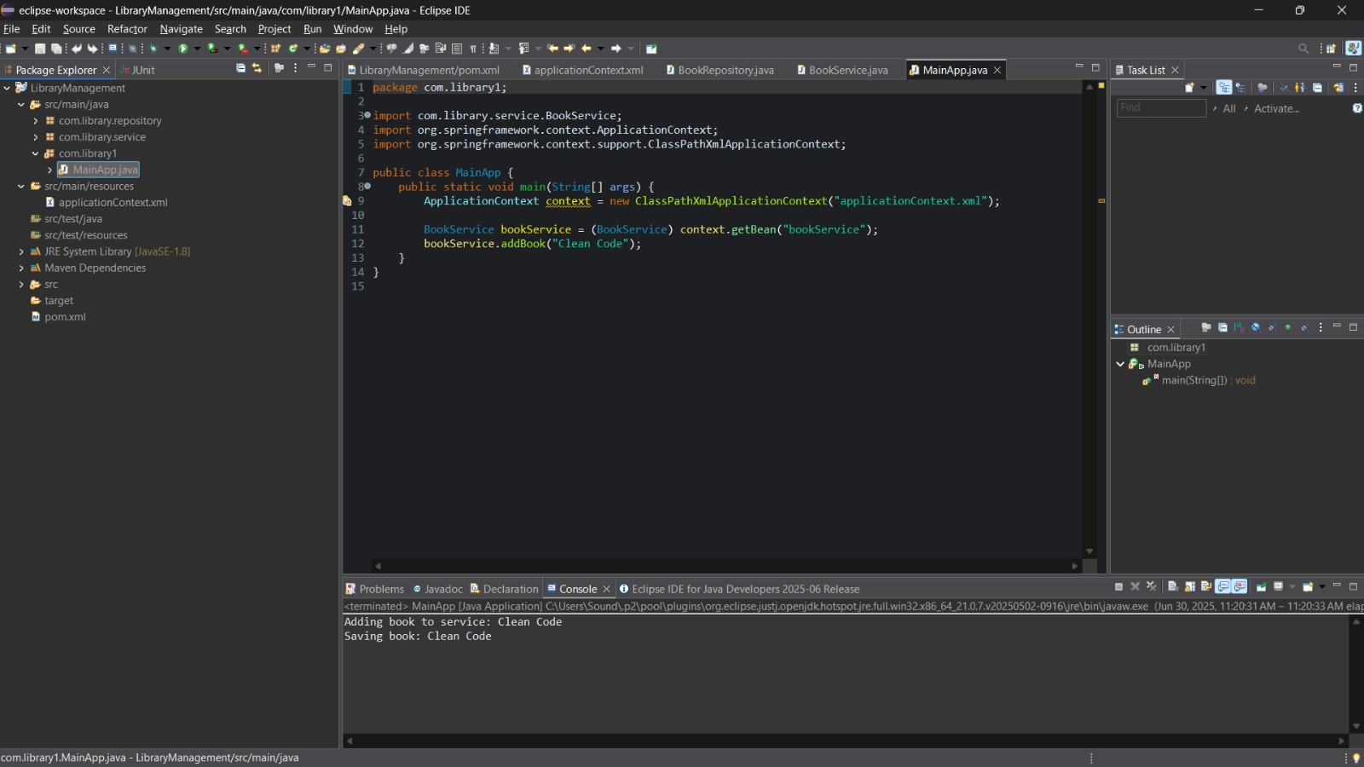

**Exercise 4: Creating and Configuring a Maven Project**

**Code:**

**Pom.xml:**

<project xmlns="http://maven.apache.org/POM/4.0.0"

xmlns:xsi="http://www.w3.org/2001/XMLSchema-instance"

xsi:schemaLocation="http://maven.apache.org/POM/4.0.0

http://maven.apache.org/xsd/maven-4.0.0.xsd">

<modelVersion>4.0.0</modelVersion>

<groupId>com.library</groupId>

<artifactId>LibraryManagement</artifactId>

<version>1.0-SNAPSHOT</version>

<dependencies>

<dependency>

<groupId>org.springframework</groupId>

<artifactId>spring-context</artifactId>

<version>5.3.33</version>

</dependency>

<dependency>

<groupId>org.springframework</groupId>

<artifactId>spring-aop</artifactId>

<version>5.3.33</version>

</dependency>

<dependency>

<groupId>org.springframework</groupId>

<artifactId>spring-webmvc</artifactId>

<version>5.3.33</version>

</dependency>

</dependencies>

<build>

<plugins>

<plugin>

<groupId>org.apache.maven.plugins</groupId>

<artifactId>maven-compiler-plugin</artifactId>

<version>3.8.1</version>

<configuration>

<source>1.8</source>

<target>1.8</target>

</configuration>

</plugin>

</plugins>

</build>

</project>

**BookRepository.java**

package com.library.repository;

public class BookRepository {

public void saveBook(String bookTitle) {

System.out.println("Saving book: " + bookTitle);

}

}

**bookService.java**

package com.library.service;

import com.library.repository.BookRepository;

public class BookService {

private BookRepository bookRepository;

public void setBookRepository(BookRepository bookRepository) {

this.bookRepository = bookRepository;

}

public void addBook(String title) {

System.out.println("Adding book to service: " + title);

bookRepository.saveBook(title);

}

}

**MainApp.java**

package com.library;

import com.library.service.BookService;

import org.springframework.context.ApplicationContext;

import org.springframework.context.support.ClassPathXmlApplicationContext;

public class MainApp {

public static void main(String[] args) {

ApplicationContext context = new ClassPathXmlApplicationContext("applicationContext.xml");

BookService bookService = (BookService) context.getBean("bookService");

bookService.addBook("Atomic Habits");

}

}

**applicationContext.xml**

<?xml version="1.0" encoding="UTF-8"?>

<beans xmlns="http://www.springframework.org/schema/beans"

xmlns:xsi="http://www.w3.org/2001/XMLSchema-instance"

xsi:schemaLocation="

http://www.springframework.org/schema/beans

https://www.springframework.org/schema/beans/spring-beans.xsd">

<bean id="bookRepository" class="com.library.repository.BookRepository" />

<bean id="bookService" class="com.library.service.BookService">

<property name="bookRepository" ref="bookRepository" />

</bean>

</beans>

**Output:**

